ILA Awards Committee Report for the
International Loran Association
2010 Awards Presentations

Medal of Merit:
Dr Paul Williams
Dr. Paul Williams has made a 15 year contribution to the understanding and development of Loran-C and Enhanced Loran (eLoran). As a researcher at the University of Wales, Bangor, Dr. Williams played a leading role in creating a set of simulation tools, culminating in BALOR, that accurately models the variations of strength and delay of Loran signals as they propagate overland of complex conductivity and topography. His many publications represent a key resource for those who would understand low-frequency propagation.
Later, as Principal Development Engineer with the Research and Radionavigation Directorate of the General Lighthouse Authorities of the United Kingdom and Ireland, Dr. Williams bas been a key figure in the team that has taken eLoran from a feasibility demonstration to a continuously operating prototype system and demonstrated its successful use in areas of complex geography.

John M. Beukers Technical Innovation Award:
Dr. Paul Williams and Mr. Chris Hargreaves
The GLA’s have taken eLoran from a concept supported by feasibility demonstrations to a prototype system operating 24/7.
President's Award:
Cdr Gary M. Thomas
US Coast Guard Loran Support Unit
Cdr Gary Thomas, as Commanding Officer of the Loran Support Unit, made certain that the Loran-C termination in the USA was accomplished with dignity and professionalism.
In addition to orderly procedures with minimum disruption, he provided an appropriate ceremony acknowledging the tremendous service the Loran program and the Coast Guard people provided for US military services and for the maritime industry for more than 66 years.
Outstanding Service Awards: (none)

Best Paper Award:
John Pinks, Nautel
“A Small Antenna for a Temporary Short-Range Loran System”

William L. Polhemus Best Student Paper Award:
Jan Šafář, GLA’s of the UK and Ireland
“Cross-Rate Interference and Implications for Core eLoran Service Provision”

Service Awards:

Zachariah Conover, Crossrate Technology
ILA-38, 2009 Convention Chair
Chris Bartone - Ohio University
ILA-38, 2009 Convention Technical Chair

Respectfully submitted,
William F. Roland, Chair, Awards Committee Recorder
06 Nov 2010

International Loran Association

Medal of Merit

Dr. Paul Williams
Dr. Paul Williams has made a 15 year contribution to the understanding and development of Loran-C and Enhanced Loran (eLoran). As a researcher at the University of Wales, Bangor, Dr. Williams played a leading role in creating a set of simulation tools, culminating in BALOR, that accurately models the variations of strength and delay of Loran signals as they propagate overland of complex conductivity and topography. His many publications represent a key resource for those who would understand low-frequency propagation.
Later, as Principal Development Engineer with the Research and Radionavigation Directorate of the General Lighthouse Authorities of the United Kingdom and Ireland, Dr. Williams bas been a key figure in the team that has taken eLoran from a feasibility demonstration to a continuously operating prototype system and demonstrated its successful use in areas of complex geography.
In recognition of his outstanding analysis, technical contributions and leadership in bringing eLoran to the fore, the International Loran Association presents Dr. Paul Williams with its most prestigious award:
The Medal of Merit
Presented this 30th day of November, 2010

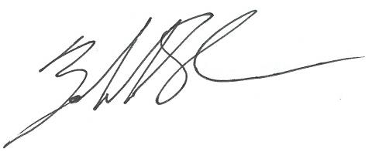

__________________________
Zachariah Conover, President

International Loran Association

President’s Award

Commander Gary M. Thomas, USCG

Cdr. Thomas is cited for his successful accomplishment in conducting the sensitive process of closing the US Coast Guard’s Loran-C radionavigation service.
Cdr. Gary Thomas, as Commanding Officer of the USCG Loran Support Unit, made certain that the Loran-C termination in the USA was accomplished with dignity and professionalism. In addition to orderly procedures with minimum disruption, he provided an appropriate ceremony acknowledging the tremendous service the Loran program and the Coast Guard people provided for US military services and for the maritime industry for more than 66 years..
In recognition of his accomplishment of this sensitive closure with concern for the public and the impact on the service, the President of the International Loran Association, with the approval of the Board of Directors presents:
The President’s Award
Presented this 30th day of November, 2010
_______________________________________ Zachariah Conover, President

International Loran Association

John M. Beukers

Award for Technical Innovation

Through teamwork and with dedication Dr. Paul Williams and Mr. Chris Hargreaves developed the technical tools and operating procedures to take the GLA of the UK and Ireland feasibility demonstration equipment of eLoran radionavigation service and develop the prototype stage with 24/7 continuous operating capability and service availability. With considerable time pressure and stringent operating requirements, they were able to complete the project within cost projections and meeting all operating requirements.

The International Loran Association makes this award with gratitude for
their invaluable contribution to Loran & eLoran:

.Dr. Paul Williams and Mr. Chris Hargreaves

Presented this 30th day of November, 2010

______________________________
Zachariah Conover, President

International Loran Association

Best Paper Award

John Pinks
Nautel Inc.
Is recognized for his outstanding contribution to Loran and the Association
in the Preparation and Presentation of the paper:
“A Small Antenna for a Temporary Short-Range Loran System”
at the 38th Annual International Loran Association
Convention and Technical Symposium 2009
Presented this 30th day of November, 2010
By Authority of the Board of Directors
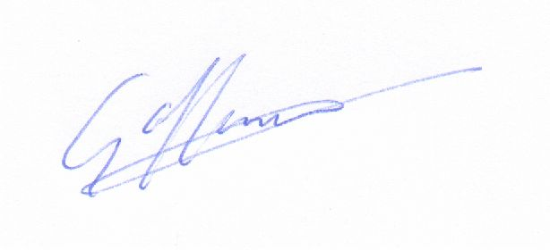

Gerald Offermans, Chair, Awards Committee

International Loran Association

William L. Polhemus Student Paper Award

Jan Šafář
GLA’s of UK and Ireland
Is recognized for his outstanding contribution to Loran and the Association
in the Preparation and Presentation of the paper:
“Cross-Rate Interference and Implications for
Core eLoran Service Provision”
at the 38th Annual International Loran Association
Convention and Technical Symposium 2009
Presented this 30th day of November, 2010
By Authority of the Board of Directors

Gerald Offermans, Chair, Awards Committee
International Loran Association

Outstanding Service Award

This is to certify that

Zachariah Conover
By virtue of his contributions to Loran and the Association as
General Chair of the
International Loran Association
38th Annual Convention and Technical Symposium 2009,
has significantly fostered the Aims and Purposes of
The International Loran Association.
Presented this Presented this 30th day of November, 2010
By Authority of the Board of Directors

Gerald Offermans, Chair, Awards Committee
International Loran Association

Outstanding Service Award

This is to certify that

Chris Bartone
By virtue of his contributions to Loran and the Association as
Technical Chair of the
International Loran Association
38th Annual Convention and Technical Symposium 2009,
has significantly fostered the Aims and Purposes of
The International Loran Association.
Presented this Presented this 30th day of November, 2010
By Authority of the Board of Directors

Gerard Offermans, Chair, Awards Committee

