The Board of Directors and the Officers of the International Loran Association welcome you to the 35th Annual Convention and Technical Symposium of the organization! This meeting marks the first time in the Groton-New London area; home to the USCG Academy. We know you will enjoy not only the meeting, but your stay in our 2006 convention city. Thank you for your interest in Loran and your support of the ILA.

Registration and Fees: If you have not yet paid your registration fees for the Convention, the GAUSS meeting, or guests attendance, please check in at the registration desk to complete these transactions.

Meeting Proceedings: ILA-35 Proceedings will be published on Compact Disk media only. The cost for the proceedings is included with the full registration to ILA-35; additional copies may be purchased separately. Check with the Registration Desk or the ILA Operations Center.

ILA-35 Sponsors: The Association gratefully acknowledges the sponsoring organizations and the individuals who contributed time and money toward this meeting.

International Loran Association
Operations Center
741 Cathedral Pointe Lane
Santa Barbara, California, USA 93111
805-967-8649
ila@loran.org / www.loran.org

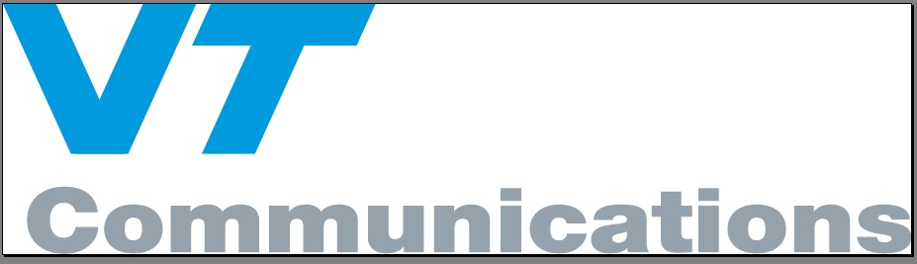



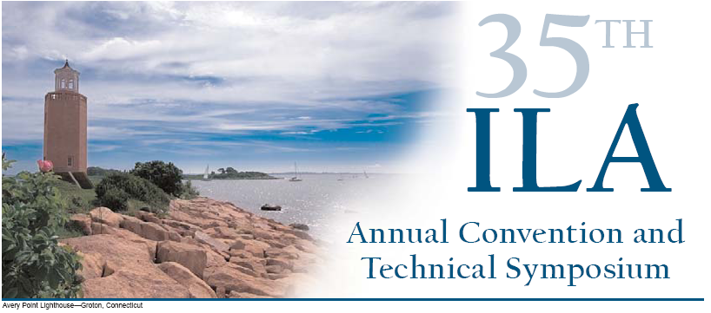
Convention Sponsors
Convention Committee, ILA-35

Chairman: Dr. Gregory Johnson GWJohnson@AlionScience.com
Technical Chairman: Prof. Peter Swaszek swaszek@ele.uri.edu
ILA President: Langhorne Bond
GAUSS Chairman: Dr. Gerard Offermans g.offermans@reelektronika.nl
Sponsorships: Dr. Gregory Johnson GWJohnson@AlionScience.com
Awards: William Roland broland@knology.net
Registration: Ellen Lilley ellen@bemorehealthy.com
Ellena Roland eroland@knology.net
Posters: Christine Cleary ccleary@megapulse.com
Photography: Ruslan Shalaev rshalaev@alionscience.com
Tech Support: Mark Wiggins mwiggins@alionscience.com
Convention Support: Christian Oates coates@alionscience.com

International Loran Association
35th Annual
Convention
and Technical
Symposium

October 23-25, 2006
Mystic Marriott Hotel and Spa
Groton, CT USA

“2006 – The Year of Loran”




35th Annual Convention and Technical Symposium

Mystic Marriott, Groton, CT

Sunday, October 22, 2006

6:00 - 8:00 pm Early-Arrival Reception
At the Johnsons’ home, 16 Elm Ave., Norwich, CT

Turn left out of the Marriott. Turn left onto I-95 South. Take exit 84 for Rt 32 North. Stay straight on RT 32 North for a couple of miles. Take the right-hand entrance for I-395 North. Take exit 82 for Norwichtown. At the end of the exit ramp turn right onto West Town St. Go ½ mile to the stop sign; congregational church will be on your left. Go straight to next stop sign; Norwichtown Green will be on your right. Turn right onto Elm Ave. Number 16 is on the left towards the end (yellow house). Lost? Call 860-887-6064.

Monday, October 23, 2006

9:00 am GAUSS Standardization Committee Meeting
Mystic Salon A

1:00 pm 146th ILA Board of Directors Meeting
Mystic Salon A

4:00 – 5:30 pm* Registration/Information desk open

6:00 – 8:00 pm Icebreaker Reception – Conference Room 7

Tuesday, October 24 – General Sessions

All general sessions are in the Marriott Salon D

7:30 am Informal Continental Breakfast

7:30 – 10:30 am* Registration/Information desk open

8:00 - 8:30 am Welcome Remarks

Gregory Johnson, Conference Chairman
Peter Swaszek, Technical Chairman
Langhorne Bond, ILA President

8:30 - 10:00 am Session 1 – Loran Status around the World
Chair: Sherman Lo, Stanford University

The eLoran Evaluation and Modernization Program - A Decade of Excellence, Mitchell Narins, US Federal Aviation Administration
The GLA’s Loran Programme and Current Status in Europe, Sally Basker, General Lighthouse Authority, and David Last, RIN President
Update on FERNS, Tamotsu Ikeda, SENA, and Seung-Gi Gug, Korea Maritime University
US Loran Modernization Update, CDR Christopher Nichols, USCG Loran Support Unit
Status of U.S. Loran Program and Policy, CDR John Merrill, USCG Headquarters
FY06 US Loran Performance Review, Lt Matthew Will, USCG NAVCEN West

10:00 - 10:30 am Morning Break

10:30 - 12:00 n Session 2 – Loran in the GPS World
Chair: James Carroll, Volpe National Transportation Systems Center

Test Results of the e-Tracker – a New Modular and Flexible Loran-C based Goods Tracking System, Marc Clerens, ELSIS AG (presented by Peter Swaszek)
Signals of Opportunity: Loran in the World's "Areas of Interest", Robert Lilley
Genesis of Loran Augmented Satellite Navigation, John Herther, MITRE
Comparing the Timing Capability of LORAN to Industrial Timing Requirements, Michael Lombardi, NIST
TRI-NAVTM Integrating LORAN, GPS, INS, and Timing for a Total Navigation Solution, Gary Steimer and Stephen Smith, Oak Ridge National Laboratory

12:00 - 1:30 pm Lunch – Marriott Salon F
Speaker: John Beukers, Past ILA President

1:30 - 3:15 pm Session 3 – Loran in Aviation
Chair: Lt. David Lown, USCG Loran Support Unit

Loran C Accuracy Considerations: Terminal Area and en Route, David Diggle, Ohio University, and Mitchell Narins, US Federal Aviation Administration
Assessing Loran for RNP 1.0, Sherman Lo and Per Enge, Stanford University
A Potential Role for eLoran in Aviation Surveillance, James Carroll, Volpe National Transportation Systems Center
The Big Picture on ASFs: the Validity of Predicted ASFs over Long Distances, Ruslan Shalaev, Gregory Johnson, Alion Science & Technology, Peter Swaszek, University of Rhode Island, Capt Richard Hartnett, USCG Academy, and Christian Oates, Alion Science & Technology,
Demonstrating the Integrity Loran Cycle Selection, Sherman Lo and Per Enge, Stanford University

3:15 – 3:45 pm Afternoon Break

3:45 – 5:30 pm Session 4 – Loran for Harbor Entrance & Approach
Chair: David Diggle, Ohio University

Differential Loran Trials in Harwich Harbour, Gerard Offermans, Arthur Helwig, Reelektronika, Paul Williams, Trinity House, and Wouter Pelgrum
Methods for developing ASF grids for harbor entrance and approach, Peter Swaszek, University of Rhode Island, Gregory Johnson, Alion Science & Technology, and Cpt Richard Hartnett, USCG Academy
High Precision Differential Loran – Tampa Bay Revisited, Wouter Pelgrum,
High Performance Evaluation of Loran as a DGPS Backup System in the HEA Domain Using a Target Level of Safety Criterion, Peter Morris, Stanford University
The Loran Data Channel; Progress to Date and Future Plans, Benjamin Peterson and Ken Dykstra, Peterson Integrated Geopositioning

7:00 – 9:00 pm Reception, USCG Academy Alumni Center
Museum open 6:00 - 9:00 pm
Carpool Transportation; Maps will be provided

Wednesday, October 25 – General Sessions

All general sessions are in the Marriott Salon D

7:30 am Informal Continental Breakfast

8:30 – 10:30 am* Registration/Information desk open

*The registration and Information desk will be open at the times indicated above. The desk may be open at other times also.

8:00 -10:00 am Session 5 – Noise and ASF Variation
Chair: Kevin Bridges, US Federal Aviation Administration

High-Voltage: P-static Test and Evaluation Facility at the FAA Technical Center, Robert Lilley, Aviation Management Associates, and Robert Erikson, W J Hughes FAA Technical Center
LDaC: A Wideband Loran Data Acquisition System, Gregory Johnson, Alion Science & Technology
Recent Ohio University LORAN-C Atmospheric Noise Flight Test Results, Curtis Cutright, Janet Blazyk, David Diggle, and Frank van Graas, Ohio University
Evaluating Atmospheric Noise Mitigation Techniques, Lee Boyce, Stanford University
Warping Time and Space: Spatial Correlation of ASF Temporal Variations, Michael Kuhn, Gregory Johnson, Alion Science & Technology, Peter Swaszek, University of Rhode Island, Capt Richard Hartnett, USCG Academy, and Mark Wiggins, Alion Science & Technology
An Examination of Loran Signal Temporal Propagation Variations, Robert Wenzel, Booz Allen Hamilton, Peter Morris, Stanford University, and Lt Kirk Montgomery, USCG Navigation Center

10:00 - 10:30 am Morning Break

10:30 - 12:00 n Session 6 – eLoran Applications
Chair: Durk van Willigen, Reelektronika

Development and Implementation of the Loran TOA Measurement System, Wouter Pelgrum, David Diggle, Ohio University, and Arthur Helwig, Reelektronika
The State of Loran Data Channel (LDC) and Two Way Satellite Time/Frequency Transfer (TWSTFT) Research and Development, Lt Kevin Shmihluk, USCG Loran Support Unit
LORADD UTC Timing and Frequency Trials, Arthur Helwig, Gerard Offermans, Reelektronika, and Chris Farrow, Chronos
Backup Strategies for Navigation and Surveillance, Gary Church, Michael Harrison, and Robert Lilley, Aviation Management Associates

12:00 - 1:30 pm Lunch – Mystic Salon F
ILA Annual Membership Meeting – Langhorne Bond
Service Awards – Bill Roland, ILA Awards Chair

1:30 - 2:50 pm Session 7 – Navigation Safety Panel
Chair: Langhorne Bond, ILA President

Sally Basker, General Lighthouse Authority
Cpt Bill Brogdon, USCG retired
Earl Waesche, Legislative Director, National Boating Federation
Brad Wheeler, Marine Operations, International Registries

2:50 – 3:20 pm Afternoon Break

3:20 - 5:00 pm Session 8 – Loran Markets and Policy
Chair: Benjamin Peterson, Peterson Integrated Geopositioning

ACO Summary Description and Analysis, Erik Johannessen, Megapulse
Integrated eLoran/GPS Receivers: An Overview of Markets and Commercialization, Zachariah Conover and Michael Leathem, CrossRate Technology
Loran’s Role in Future PAT, Erik Johannessen, Megapulse
An Update to Modernized Loran; LEMS/LICOS Requirements Project, Wayne Wawrzyniak, USCG Loran Support Unit
Radionavigation – the only way to go?, Durk van Willigen, Reelektronika

5:00 – 6:00 pm 147th ILA Board of Directors Meeting – Conference Room 2

6:00 - 7:00 pm Reception – Pre-Function Area

7:00 - Banquet – Mystic Salons B & C
ILA Awards Presentation
Speaker: Don Treworgy, Director of the Mystic Seaport Planetarium

